**Personal Assistance for Seniors Who Are Self-Reliant**

**Assignment – II**

**Topic :**PYTHON CODE TO GET TEMPERATURE AND HUMIDITY VALUE

**Name:** PARKAVI.V

**RegisterNumber:** 921019104035

**E-Mail Id :**[parkaviparkavi996@gmail.com](mailto:parkaviparkavi996@gmail.com)

**Code:**

import random

while(True):

temp=random.randint(10,99)

humid=random.randint(10,99)

print("current temperature: ",temp)

print("current humidity:",humid,"%")

temp_ref=35

humid_ref=50

if temp >temp_ref and humid <humid_ref:

print("Alarm On")

else:

print("Alarm off")

break

**OUTPUT**

**ALARM OFF**

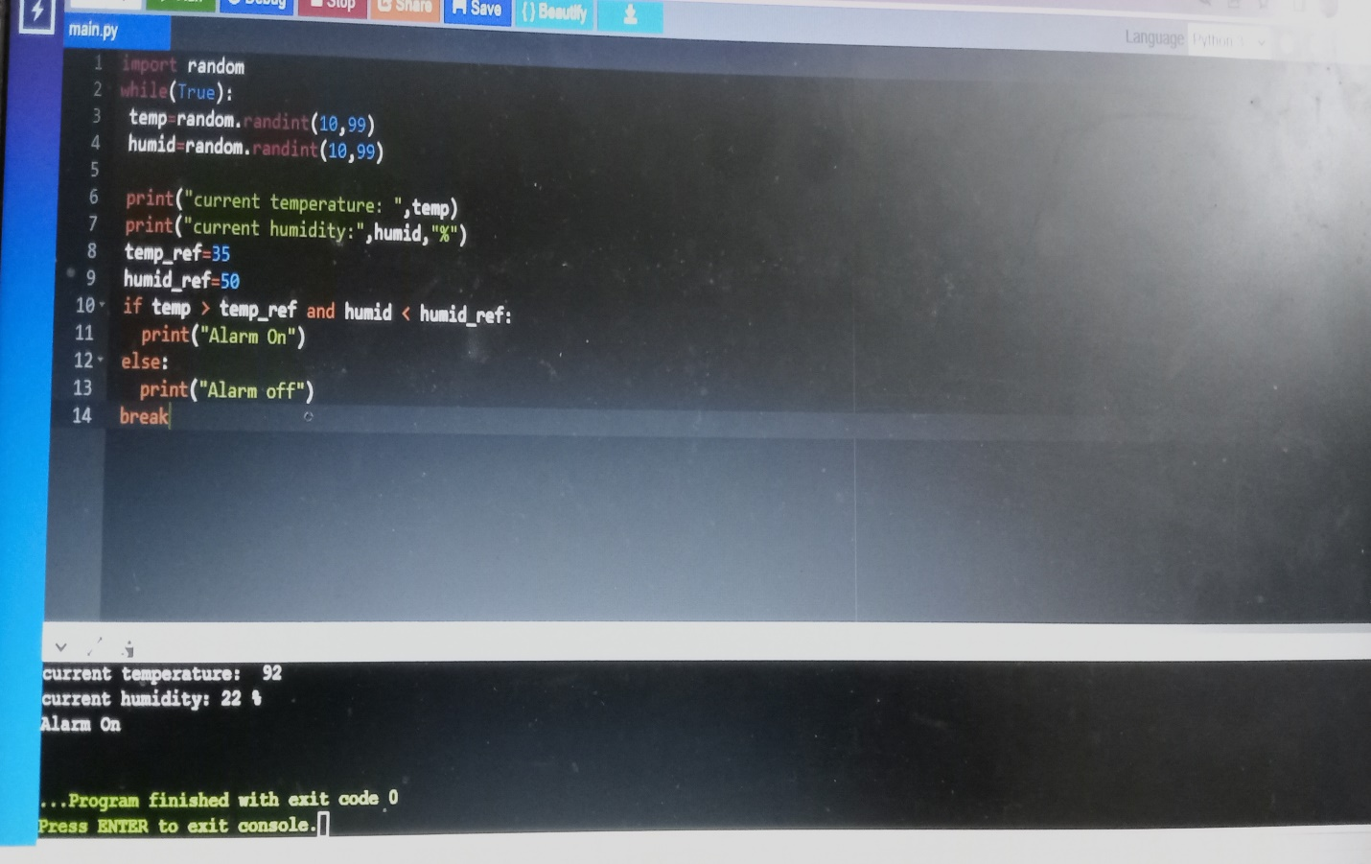

**ALARM ON**

